Project Vision and Scope

**Project background**

Hooked is a cross of Celeste and The Legend of Zelda. You play as Jason, a small kid on a big quest. Jason leaves home with two goals: to defeat three evil kings and save his home from being taken over. He shoots a grappling hook, a multipurpose weapon, to make his way through any challenge.

**Stakeholders**

The stakeholders for the project are every member of the ‘Platformers,’ in addition to Professor Perez-Davila and the members of the class who wish to play the game.

**Users**

The Users for the game ‘Hooked’ is anyone who wishes to play the game, referred to as ‘Players’. There are no official age ratings for the game, though it is slated to have content that is suitable for most ages. The presence of a crossbow and arrows may make the game unsuitable for particularly young children.

**Risks**

Unity or GitHub gets taken down

Internet goes down for extended period of time

Power goes out for extended period of time

Master file is corrupted

**Assumptions**

It is assumed that the Player’s system has enough disk space to run the game as well as enough memory to handle Unity. Users on old laptops might be able to play, though remaining plugged in may be necessary for such users as Unity can be a power-hog.

**Vision of the Solution**

Our vision is a Pixel-art 2D platformer that incorporates seamless movement with a Grappling hook. The Player will traverse multiple levels with the goal of reaching the end within the time-limit. Enemies and collectibles will be present to provide challenge to the player, and will provide score points through defeat or collection.

We hope to incorporate different levels, a forest, cave, and fortress; each with different art, enemies, interactables, and obstacle behaviors (For example, the Forest level may be relatively straightforward, focusing on moving platforms, while the Fortress Level incorporates doors which must be opened with a button somewhere in the level).

We hope to use momentum-based movement to allow the player to utilize their creativity with their movement options to maintain as much speed as they can. We intend to put as few limits on these movement options as possible, enough to prevent outright breaking the game but not so much that it renders experimentation pointless.

**List of features:**

The Player Character (PC) will be capable of:

* Moving (Running, Jumping, Crouching, Dashing, etc…)
* Firing either arrows (to defeat enemies) or a Grappling hook (To pull the PC to a location)
* Collecting coins and collectables
* Interacting with objects for score and/or to progress

We will have three separate locations each which:

* Have unique art (stencils)
* Have unique enemies
* Have unique obstacles

The core challenges the player will face are:

* A time limit which the player must beat each level within, alongside the obstacles designed to delay players.
* 3 bosses, each of which must be beaten in conjunction with platforming (The act of preventing the PC from falling by jumping over or around obstacles).

The Player will have a UI which allows them to:

* Manually save (In addition to the automatic saves provided by waypoints)
* View their health
* View the timer
* Pause
* Return to the title screen

**Desirable features**

* Secrets hidden in each level, range from an alternate path with additional coins as a reward for the player to easter-eggs members of the ‘Platformers’ team may decide to hide.
* Power ups, either temporary or permanent, to reward the riskier players that take the time to obtain them.

Project Plan

The Project Plan should consist of:

· A statement of work (SOW) that describes all work products that will be produced and a list of team members who will perform that work

· A resource list that contains a list of all resources that will be needed for the project and their availability

· A work breakdown structure and a set of estimates

· A project schedule identifies the tasks that are in the critical path

· A risk plan that identifies any risks that might be encountered and indicates how those risks would be handled should they occur if appropriate

**Statement of Work**

1 Project Description

The final product will be a 2D platform game. The main feature of this game that will set it apart from other 2D platform games is a grappling hook mechanic that will allow the player to shoot onto a surface and bring the user to that location.

2 Key Assumptions

This game should not be very demanding in terms of computer resources. Assumptions include having enough memory, disk space, etc.

3 Scope of Services

List the specific features, functions, capacity, performance, and qualities required in the Work Product, any exceptions, and any that are prohibited.

This game will have features such as a grappling hook mechanic that will allow the player to move from point A to point B, multiple levels, enemies that pertain to each level, different core obstacles dependant on each level, a UI with all of the information the player will need to avoid losing.

4 Milestone Deliverables

Sprites for

* Character
  + full character design and all sprites necessary to create the animations for character movement
  + Will be worked on by Melissa and John
* Environment
  + Full environment sprite sheet and palette necessary to create the levels
  + Will be worked on by Melissa and John
* Enemies
  + Enemy sprite sheet necessary to create enemy animation
  + Will be worked on by Melissa and John
* Items
  + Sprite sheet for all items including decorations to be used in the game and needed for animations
  + Will be worked on by:
* UI icons
  + Icons need for both settings menu and HUD
  + Will be worked on by:

Scripts for

* Player movement
  + C# code used to allow players to move across the map including forward, backward, jumping, dash, etc…
  + Will interact with player movement animations
  + Will be worked on by: Patrick
* Player attack
  + C# code used attack
  + Will interact with player movement animations
  + Will be worked on by:
* Grappling hook
  + C# code used grapple to platforms or to attack enemies
  + Will interact with grappling hook animations and player movement animations
  + Will be worked on by:
* enemy AI
  + Multiple C# scripts for various enemies to control their movement and attacking patterns
  + Will interact with enemy animations
  + Will be worked on by: Mario
* UI menu and HUD
  + Multiple C# scripts for the settings to control things like sound, save, etc.. and to control the display of the health bar, timer and score of the HUD
  + Will be worked on by: Mario
* Camera movement
  + C# script to make camera follow player smoothly across the map
  + Will be worked on by:
* Interactables
  + C# script to allow player to interact with items such as chests, doors, coins, etc
  + Will be work on by:

Animations:

* Player movement
  + Player movement state machine to allow idle, forward, backward, jumping, dash, etc
  + Will be worked on by:
* Grappling hook
  + Grappling hook state machine to allow to hook onto platforms and to attack enemies
  + Will be worked on by:
* Enemies
  + Multiple enemy state machines for each of the varying enemies and bosses
  + Will be worked on by:

Documents:

* Character design
  + Character illustrations for front, back, and side view as well as the movement views.
* Enemy design
  + Enemy designs illustration with front, back and side views
* Boss design
  + 3 Boss designs illustrations
* Level outline/ design
  + Blueprint for different levels
* Story
* Testing
  + Checklist and statistics of game performance

Final Product:

* Full game in one package ready to be played

5 Duration of Services

Provide details for the project schedule and resource plan agreed upon to achieve project milestones. Project start and end dates should be clearly defined.

The development of our game will begin on 6/7/2021 and is slated to, for the purposes of Senior Project, end on 12/3/2021. Any additional development someone from the team dedicates to the project beyond this point is done of their own volition.

6 Acceptances

‘Hooked’ will be considered a success if 75% of the class voices a positive, or neutral with criticisms, opinion of the game, post-presentation.

**Resource List**

Unity Engine

Team members

Discord

GitHub

Aseprite

**Work Breakdown Structure**

Estimates, in person-hours, including both development and post-development tweaking: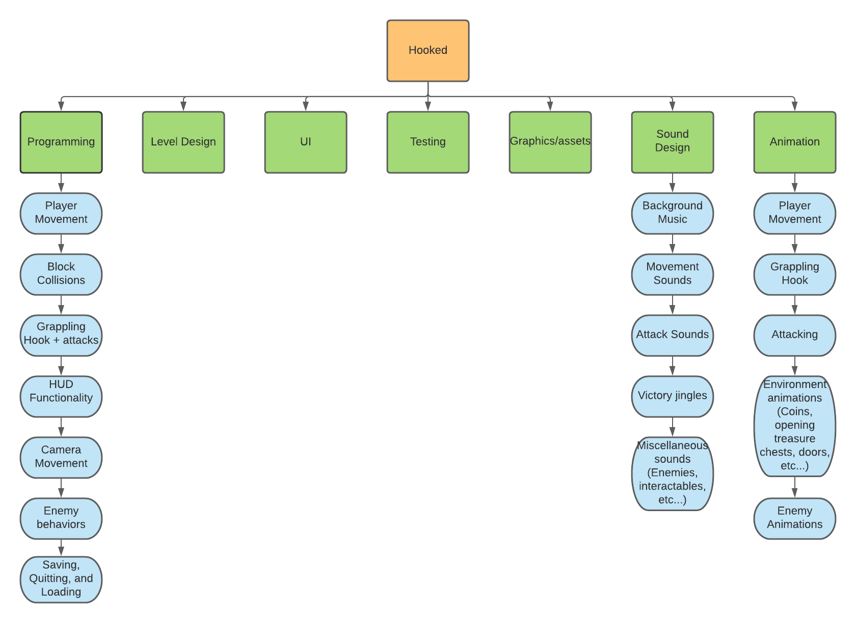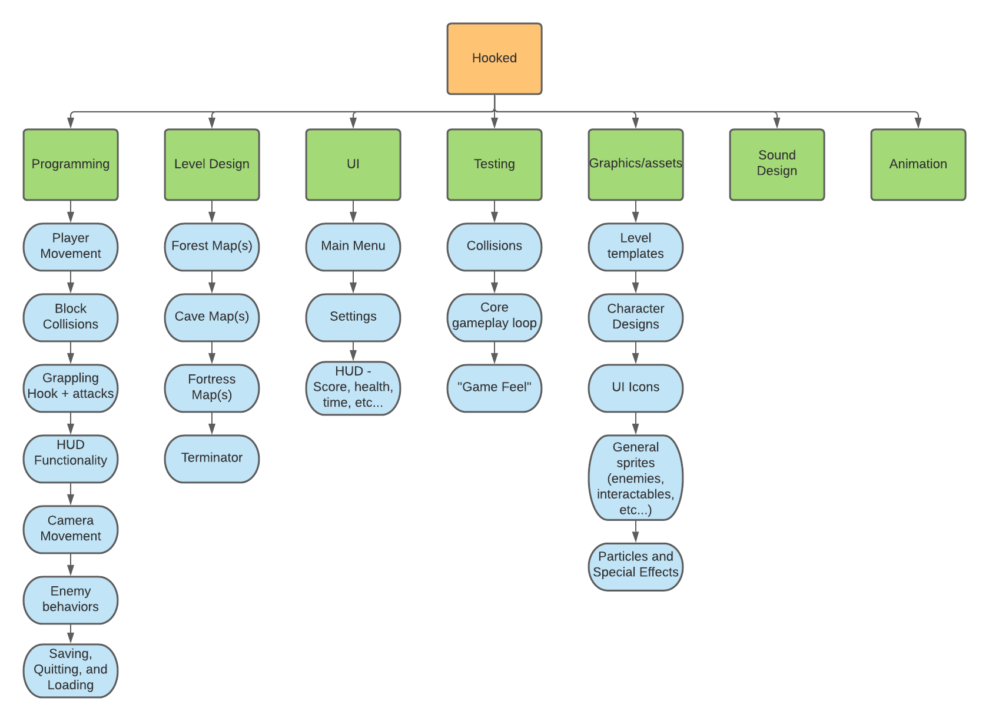

Programming - 20 hours.

Level Design - 5 hours.

UI - 5 hours.

Testing - 10 hours.

Graphics/assets - 20 hours.

Sound Design - 10 hours.

Animation - 15 hours.

**Dependencies:**

* Finish to start:
  + Player movement animation → Player character sprites
  + Attacking → player character sprites and weapon sprites
  + Enemy animations → enemy sprites
  + Boss animations → boss sprites
  + Grappling hook animations → grappling hook sprites
  + HUD functionality → UI: HUD
  + UI: HUD → Graphics: UI icons
* Start to start:
  + Character sprites creation → character design
    - Logic behind this is that you can simultaneously work on the design and the creation of the sprites for the character
  + Enemy sprite creation → enemy design
* Finish to Finish:
  + Program sound effects → sound design (the whole category)
    - Logic behind this is that we can use place holders for sound and replace once we have finalized sound designs.

**Project Schedule + Critical Path**

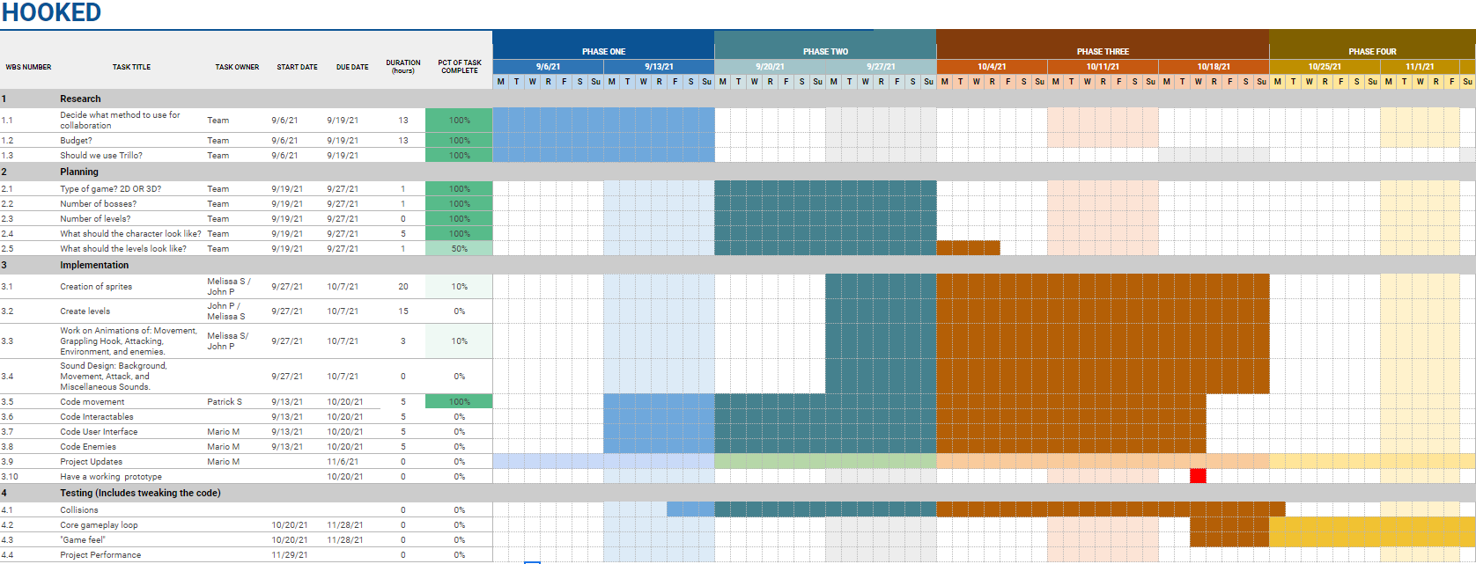

**Risk Plan**

|  |
| --- |
| Risk plan for project Hooked |

|  |
| --- |
| Assessment team members Dillon Welsh, Mario Mendoza, Patrick Sepnio, Melissa Salinas, Z, John Paduh |

|  |  |  |  |  |
| --- | --- | --- | --- | --- |
| Risk | Prob. | Impact | Priority | Actions |
| Unity gets taken down | 1 | 5 | 5 | 1. Search for an archived version of Unity online with which to utilize.   OR   1. Utilize a different engine, such as Unreal Engine. |
| Github gets taken down | 1 | 5 | 5 | If this happens, we will either search for another github-esque file project organizer or continue through a highly organized shared Google Drive. |
| Internet goes down for extended period of time | 2 | 5 | 10 | If this happens, we can attempt to transfer files over mobile data (such as with hotspots) or organize a meeting place to transfer files locally. |
| Local Power goes out for an extended period of time | 3 | 5 | 15 | If this happens, those of us without generators would need to look for a location that has generators of their own, perhaps to another person on the team or the University. |
| Master File gets corrupted | 2 | 5 | 10 | To mitigate the risks of this, we can keep manual backups on different disks, flash drives, google drive, etc(…). If we still somehow lose our master file, we can still keep most of our progress (like code, art, etc…) in different files to pull later. |